Date: 22/12/2021

**Requirement -**

1. The application is to manage the asset register.
2. Use same database of Assignment 3rd.
3. The pages are Asset List, Vendors, Add new assets, Update assets and reports.
4. The menu items should have Home, Vendors, Asset List, New Asset, Report.
5. Use Layout page for menu, header and footer.
6. The form design should be in proper alignment.
7. All the messages, warning, errors should be user friendly.

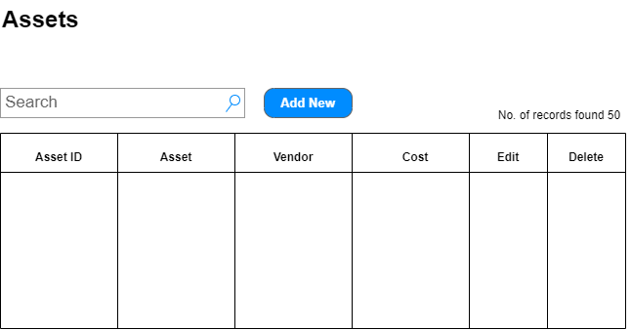

Fig.: 1

1. Able to see all the records on the page load with descending order of Purchase date.
2. Able to search the records by Asset and Vendor
3. Able to sort the data
4. Able to open the Edit form on the click of Edit link
5. Able to delete data on the click of Delete link
6. Able to select record by clicking on the Asset ID hyperlink.
7. Able to open the Add form on the click of Add New button.

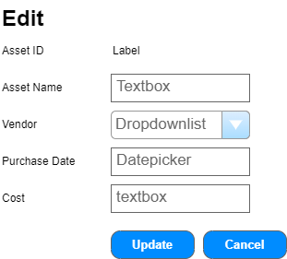

Fig. 2

1. Able to populate the record on selection of Asset ID from table shown in Fig. 1
2. **Use partial view.**
3. Able to update record.
4. Asset ID should be populate on in Label control.
5. Able to update unique asset names.
   1. Duplicate names are not allowed
   2. Allow only alphabets
   3. Max. Length should not be exceeds 100 char.
   4. Mandatory field
6. Able to bind dropdownlist with the Vendor list from Vendor Master.
7. Able to select Vendor from dropdownlist
   1. Mandatory field
8. Able to select purchase date from date picker
   1. Future date can not be selected
9. Able to enter Cost in rupees
   1. Only Numbers are allowed
   2. Mandatory field.
10. Able to redirect to list after successful updation.
11. Able to show failed message if there is error or exception.
12. Able to show successful message on redirected list page after successful updation.
13. Able to redirect to list page on the click of Cancel button.
14. Use only validation controls wherever required.

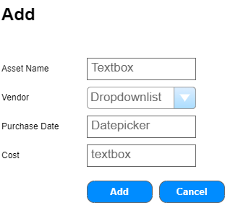

Fig. 3

1. Able to add new Asset.
2. **Use partial view.**
3. Able to generate Asset ID automatically.
4. Able to add unique asset names.
   1. Duplicate names are not allowed
   2. Allow only alphabets
   3. Max. Length should not be exceeds 100 char.
   4. Mandatory field
5. Able to bind dropdownlist with the Vendor list from Vendor Master.
6. Able to select Vendor from dropdownlist
   1. Mandatory field
7. Able to select purchase date from date picker
   1. Future date can not be selected
8. Able to enter Cost in rupees
   1. Only numbers are allowed
   2. Mandatory field.
9. Able to redirect to list after successful addition.
10. Able to show failed message if there is error or exception.
11. Able to show successful message on redirected list page after successful addition.
12. Able to redirect to list page on the click of Cancel button.
13. Use only validation controls wherever required.

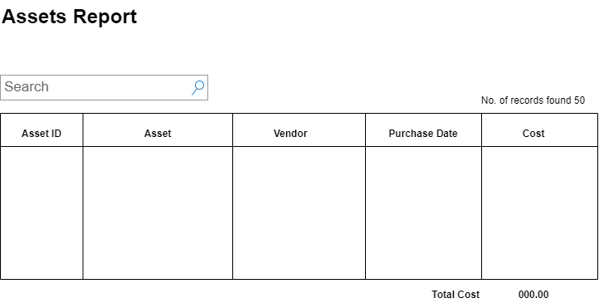

Fig. 4

1. Able show the Asset report in the format shown in Fig. 4
2. The report should be shown in ascending order of Purchase Date.
3. The Total cost is the sum of cost column.
4. Able to search by Asset and Vendor.
5. The total should be minus after deleting any asset and vice - versa.